  



**October, 2021 Newsletter for website**

Nonprofit Quarterly:

# Avoiding COVID-19 Scams Covid-related scams have bilked Americans out of $586 million

PUBLISHED MON, OCT 18 202111:07 AM EDT in CNBC online

[Greg Iacurci](https://www.cnbc.com/greg-iacurci/)[@GREGIACURC](https://twitter.com/@GregIacurci)

**KEY POINTS**

* Scams linked to the Covid-19 pandemic have cost Americans $586 million since the beginning of 2020, according to the Federal Trade Commission.
* The typical victim lost $392, as measured by the median fraud loss. Online shopping scams were the most prolific type of fraud.
* Pandemic scams are on the decline. The number of daily consumer fraud reports is at its lowest level since mid-March 2020.

Consumers have lost $586 million to fraud linked to the Covid-19 pandemic, according to [data](https://www.ftc.gov/enforcement/data-visualizations/explore-data) from the Federal Trade Commission.

Americans filed more than 269,000 fraud complaints from the beginning of 2020 to Oct. 14, 2021, according to most recent federal data. (Consumers cited Covid, stimulus or related terms in the complaints.)

The typical victim (as measured by the median) lost $392, in a range of schemes targeting online shoppers, travelers and others. The losses skew higher for older Americans: Seniors over age 80 lost $1,000 each.

However, pandemic-related scams appear to be declining, officials report.

There were 273 consumer complaints filed Thursday (as measured by the rolling 14-day average), according to FTC data. That’s the lowest level since March 16, 2020.

It’s also about eight times less than the 2,100-daily-complaint peak in early April this year, around the time Covid vaccinations were beginning to be deployed more broadly and the federal government was issuing $1,400 stimulus checks authorized by the American Rescue Plan.

Online shopping accounted for the largest number of reported scams to the FTC, at about 57,600 complaints.

Americans increased their online shopping activity during the pandemic, since they were spending more time indoors.

But many were victims of “opportunistic websites” claiming to sell popular, in-demand items — anything from hand sanitizer and gloves to electronics, clothing and even puppies, according to the FTC. Customers ordered the items but then never received them.

Price-gouging was also prevalent. It was the most commonly reported pandemic-related issue in 2020, [according](https://consumerfed.org/reports/2020-consumer-complaint-survey-report/) to state and local consumer agencies polled by the Consumer Federation of America. Consumers complained of being charged exorbitant prices for sought-after products such as hand sanitizer, toilet paper and masks.

State and local agencies also received Covid-associated complaints in a wide range of other categories, such as evictions, canceled events and travel, schools and child care, the report said.

Victims lost the largest amount of total money ($81 million) to vacation and travel scams, according to FTC [data](https://public.tableau.com/app/profile/federal.trade.commission/viz/COVID-19andStimulusReports/FraudLosses). Most fraud relates to refunds and cancellations, the agency said.

The true scope of consumer complaints and losses is likely much higher than official statistics indicate, since the data is self-reported by consumers.

Nonprofit Quarterly:

Philanthropic Pledges for Racial Justice Found to be Superficial

By Anastasia Reesa Tomkin

Contrary to popular belief, the uprisings of 2020 did not cause an enormous spike in funding for racial justice. It would be more accurate to say that there was a spike in pledges, solemn corporate PR statements, and misleading headlines, none of which translated to significant funding for the kind of Black-led, grassroots organizing that generated an unprecedented social response to racial injustice. These are the findings of an extensive 92-page report by the Philanthropic Initiative for Racial Equity (PRE), entitled [Mismatched: Philanthropy’s Response to the Call for Justice](https://racialequity.org/mismatched/).

The report stands out from others of its kind in three ways: It focuses on the number of actual grants awarded rather than grants pledged, analyzes trends over time by comparing 2020’s figures with figures from 2011 through 2018, and makes an important distinction between the concepts of racial equity and racial justice. Each of these nuances paints a full picture of why it is harmful to believe that philanthropy saw the light in 2020 and was motivated to invest in transformative change. In truth, there are major areas that philanthropists still need to improve in order to realize their full potential for supporting marginalized communities.

Understanding the difference between funding racial equity and funding racial justice is a good place to start. Racial equity constitutes programs and projects that focus on acknowledging and responding to racial differences in social outcomes. For a visual allegory, imagine scooping water out of a boat that has a hole in it. Racial justice, on the other hand, is sustainable power-building in communities of color—essentially, the work of plugging the hole in the boat. Most grants are awarded to support racial equity, fulfilling the immediate needs of disadvantaged populations but ignoring the systemic change required in order to empower them in the long term. In context, while only six cents of every philanthropic dollar awarded in 2018 went towards racial equity, a single penny went towards racial justice.

pg. 45 of Mismatched: Philanthropy’s Response to the Call for Racial Justice by PRE

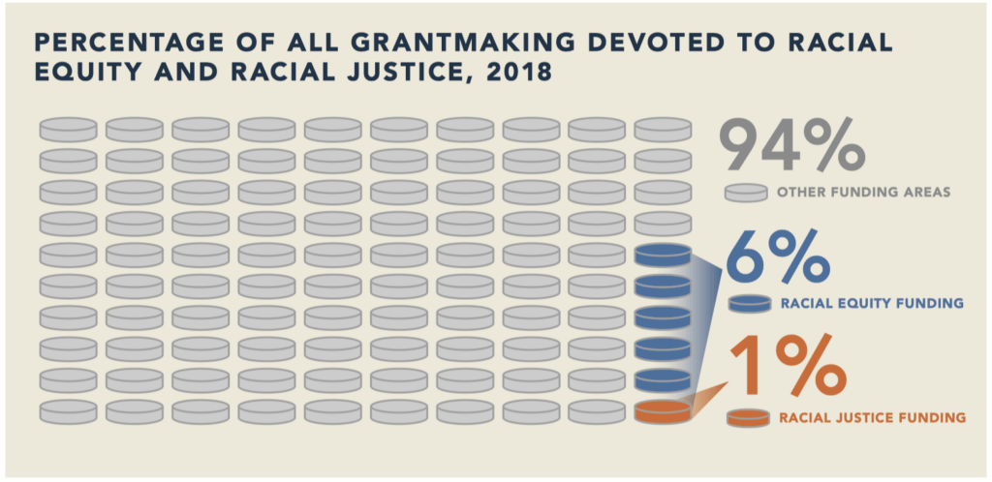

#### The Epidemic of Inflated Estimates

In those emotionally charged weeks following George Floyd’s murder by a Minneapolis policeman, there was an influx of businesses and foundations alike pledging large dollar amounts as part of their commitment to joining the fight against racial injustice. Media outlets and think-tanks were eager to count up all the pledges and subsequently report that Black-led organizations were now receiving astronomical support. The Wall Street Journal published an article in September 2020 claiming that there was $6.5 billion committed to achieving racial equity that year, dwarfing the roughly $3.3 billion of the previous eight years combined, and further indicating that most of these grants were going “specifically to nonprofits with Black leaders.” The PRE contests that this amount was “vastly overstated and mischaracterized.” Based on their analysis of the available data, there was $1.5 billion in awarded grants focused on racial equity in Black communities, a 50 percent increase compared to previous years, but nowhere near the scale of what is widely reported.

pg. 63 of Mismatched: Philanthropy’s Response to the Call for Racial Justice by PRE

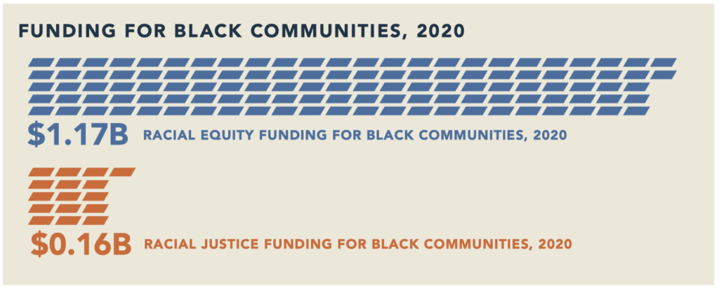

Furthermore, many of those intended pledges were allocated questionably. For example, Facebook issued a standard heartfelt statement, along with a press release detailing a staggering $1.1 billion committed to racial equity. The fine print? It would actually be $100 million in cash grants and ad credits for Black creators, nonprofits, and small businesses. The other billion dollars was allocated to “Black and diverse suppliers, including facilities, construction, and marketing agencies.” Likewise, although Microsoft made pledges of $929 million for racial equity, they indicated that $875 million of that was allocated to internal commitments, such as increasing spending on Black-owned suppliers.

Research shows that Facebook and Microsoft’s funding priorities are far from an anomaly. The Washington Post estimates that more than 90 percent of the $49.5 million in racial equity commitments made by the top 50 companies and their foundations following George Floyd’s murder were “allocated to loans or investments they could stand to profit from, more than half in the form of mortgages.”

#### Philanthropy’s Blind Spots

Private foundations, in turn, did no better than corporations in the administration of funds intended for “racial equity.” More than a third of the top 20 grant recipients for this category were organizations founded by white billionaires or corporations advancing their own theories of change for people of color. Among smaller scale white-led organizations, there was a tendency to use funding to diversify their ranks, and not for building power in underprivileged communities. Quite a small percentage of the overall funding was awarded to grassroots organizing, meaning that just a fraction of the promised billions actually ended up in the hands of Black and Brown movement leaders advancing racial justice.

Wealthy, white donors are also prone to financing initiatives that they deem most beneficial, ignoring the areas that movement leaders have identified as priorities. Education is well funded by a handful of extremely wealthy donors, but they operate with minimal input from movement leaders, setting goals and priorities that are often counterproductive to the needs of the community. Movement leaders want more focus on funding for issues such as voting rights and criminal justice reform, but philanthropists have barely heeded that call. These areas fall within the scope of racial justice because they involve grassroots organizing for sustainable movement building and systemic change, yet racial justice receives only 10 to 20 percent of racial equity funding, which ends up being one percent of all philanthropic funding.

Grantmakers’ responses contrasting sharply with the demands of the movement is nothing new. Several years ago in Ferguson, Missouri, young black people demonstrated against the murder of Mike Brown with the largest, most sustained protests in US history. They have still not received the level of support and investments that they deserve. Corporations responded to the crisis by pouring millions of development dollars into whiter and wealthier neighborhoods, with Black neighborhoods being totally overlooked. And, while much of the giving centered on racial equity, or meeting immediate needs, the longstanding fight for racial justice went underfunded—no municipal disinvestment from the brutal policing system, and no support for Black organizers seeking lasting change. It is a disturbing pattern that repeats itself at every new uprising. While the L.A. uprisings of 1992 can be credited with laying the groundwork for the ecosystem of sponsored racial equity that exists today, the scale, focus, and consistency of funding leaves much to be desired.

pg. 66 of Mismatched: Philanthropy’s Response to the Call for Racial Justice by PRE

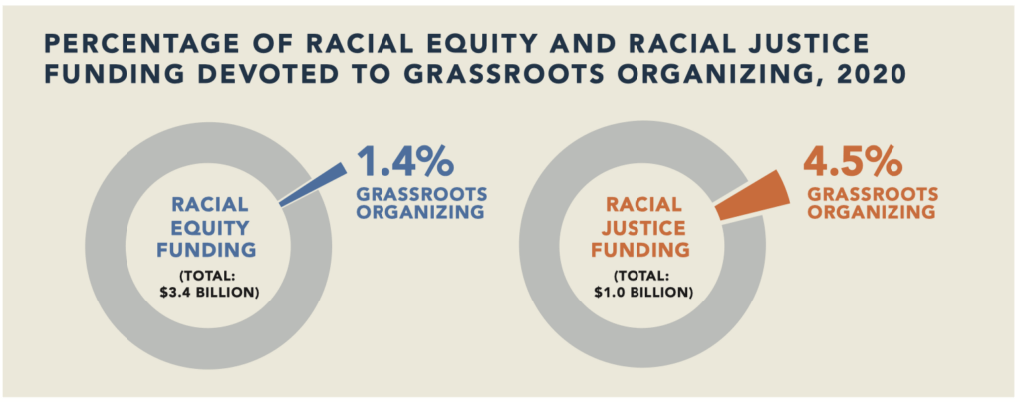

#### The Cycle of Conservative Backlash

An inaccurate assessment of the philanthropic response to uprisings is dangerous. It is fertile ground for conservative backlash to bloom, unchecked. Whenever there is a surge in crisis funding by philanthropy, corporations, and government in response to social uprising, conservative demonization and mainstream accommodation of backlash is sure to follow. They sabotage the movement’s objectives, causing grantmakers to minimize or renege on their commitments. The result is that the movement is both underfunded and further vulnerable to attack.

Backlash comes in many forms, from increased domestic terrorism to oppressive legislature. Conservatives campaign against Critical Race Theory, shut down implicit bias trainings, and oppose the prioritization of women and minorities, to name a few. The PRE notes that there is evidence linking conservative philanthropists to the attacks on Critical Race Theory. The Philanthropy Roundtable is named among them, and ironically enough, some of their major funders are the same foundations making grants for racial equity and racial justice. In philanthropic spaces, conservatives are co-opting the language of the movement to reduce its efficacy and ensure that their harmful perspectives get the same leverage and funding as anti-racist endeavors.

In order to mitigate conservative tactics, there must be sustained pressure from within the industry to finance and support racial justice. The PRE identifies comprehensive and practical solutions, and it is highly recommended for the most dedicated of grantmakers and nonprofit leaders to read them in detail. We must first understand and acknowledge the groundwork of grassroots leaders who prepared the way for more significant racial justice funding in the early ’90s. There must be greater precision in the classification of grants, allowing for the distinction between racial equity and racial justice, as well as greater efficiency in the reporting of grants.

The quantity and quality of funding should be increased, with considerations for multi-year grants and general operating support for organizations led by people of color.

For too long, communities of color have been denied the sustainable investments they rally for, in favor of shallow and/or white-centered solutions. Black, Brown, and Indigenous people must be trusted to lead and empowered to lead. Only then will significant systemic transformation improve the lives of historically marginalized people on a large scale—which, one can assume, is the overarching mission of philanthropy.

**The Chronicle of Philanthropy:**

# 4 Ways to Reshape Nonprofit Recruitment and Hiring

*By*[*Linda Nguyen*](https://www.philanthropy.com/author/linda-nguyen)

SEPTEMBER 29, 2021

By now you’ve likely heard about the [Great Resignation](https://www.npr.org/2021/06/24/1007914455/as-the-pandemic-recedes-millions-of-workers-are-saying-i-quit) — millions of workers in America quitting their jobs upon rethinking how they want to spend their time. The pandemic has caused many to reassess how ― and how much — they work.

Flexible hours and remote arrangements have largely been the focus of the Great Resignation stories we are seeing. However, social-justice organizations are also experiencing an influx of people seeking new jobs because they want more meaning and value from their work, people who want to advance the greater good.

In my work with [Movement Talent](https://movementtalent.org/), I talk with dozens of job applicants each week, and over the last year, I have heard time and again some version of the following: “When I saw this position announcement, it struck a nerve. Covid-19 has everyone assessing where their true passions lie. Not to mention the activism in the streets, racial justice. I want to be a part of an organization with greater purpose.”

Nonprofits, especially those advancing social justice, should take advantage of this moment to attract diverse talent from a variety of personal and professional backgrounds. To fully capitalize on today’s intensified interest and motivation in working for social good, nonprofits also should look critically at recruitment and hiring processes.

Movement Talent, a nonprofit that is rethinking the way organizations recruit and hire people, has been operating since the start of 2020. We’ve learned a lot, including some new approaches we believe can reshape how organizations find and hire qualified applicants. We would like to see the following changes take place, and we’ve already started working to bring them about.

**Share applicant pools.** Among organizations seeking to fill similar roles, and with the permission of applicants and organizations involved, we are presenting candidates with a broader set of job opportunities and encouraging them to make inquiries and apply to multiple organizations simultaneously.

I urge hiring managers to stop regarding these as “competing searches” and instead focus on the expanded applicant pool.

Approaching recruiting for nonprofits as an ecosystem acknowledges that the success of one hire often depends on the success of another hire at an ally organization. Why? Because in many cases, real change requires partnerships, so the person sitting next to you at a coalition table is often just as important as the person representing your organization.

**Encourage exploration.**Many organizations automatically frown upon the idea of a staff member looking at job opportunities at other organizations. This habit is often exacerbated by a scarcity mindset: “We don’t have enough resources, so we can’t afford to lose or train anyone.”

But truthfully, many positions are terminal: There is no opportunity for growth or advancement within that role. We should be open about that early on and encourage people to explore opportunities at other organizations once they outgrow a job. Supporting an employee in this way often facilitates lasting relationships and connections.

**Put candidates — not those doing the hiring — at the center of the process.** Let’s be honest: Job candidates are sometimes treated badly by our own flawed systems, either by overwhelmed HR departments or by search firms that have not caught up with the times. Candidates frequently report applying for a job and getting no response, let alone constructive feedback. With such a low bar, any improvement in job seekers’ experience will be welcome. We advise organizations to share all steps of the selection process at the outset, including the timeframe, potential interview themes, number of candidates at each stage, and feedback on interview performance to help people improve.

**Seek and share innovative hiring and talent-management practices.**We talk a lot about transparency, authenticity, collaboration, and inclusion, but do we practice this when it comes to hiring?

Imagine what would happen if nonprofit HR professionals shared experiences using new recruitment software or by designing universal templates for candidate assessments ― especially with ally organizations that have fewer resources. Let’s train one another on how to address bias in interviews. If you have a progressive compensation or leave policy, others would love to see them and adapt them to their own organization. There is a growing community of folks dedicated to making this sharing a reality, and Movement Talent is glad to facilitate it.

In a moment of tremendous flux in employment and careers, the social-justice sector has an opportunity and a responsibility to improve its recruitment and selection processes to attract more people to this vital work. It’s time to transform the hiring experience and make it a positive experience for employers and job seekers alike.